ThemAtticAthens

User/Tourist Guide

Welcome to ThemAtticAthens! Whether you're an experienced tour operator, a local guide, or a business offering unique experiences, ThemAtticAthens is here to help you reach and engage with potential clients and partners.
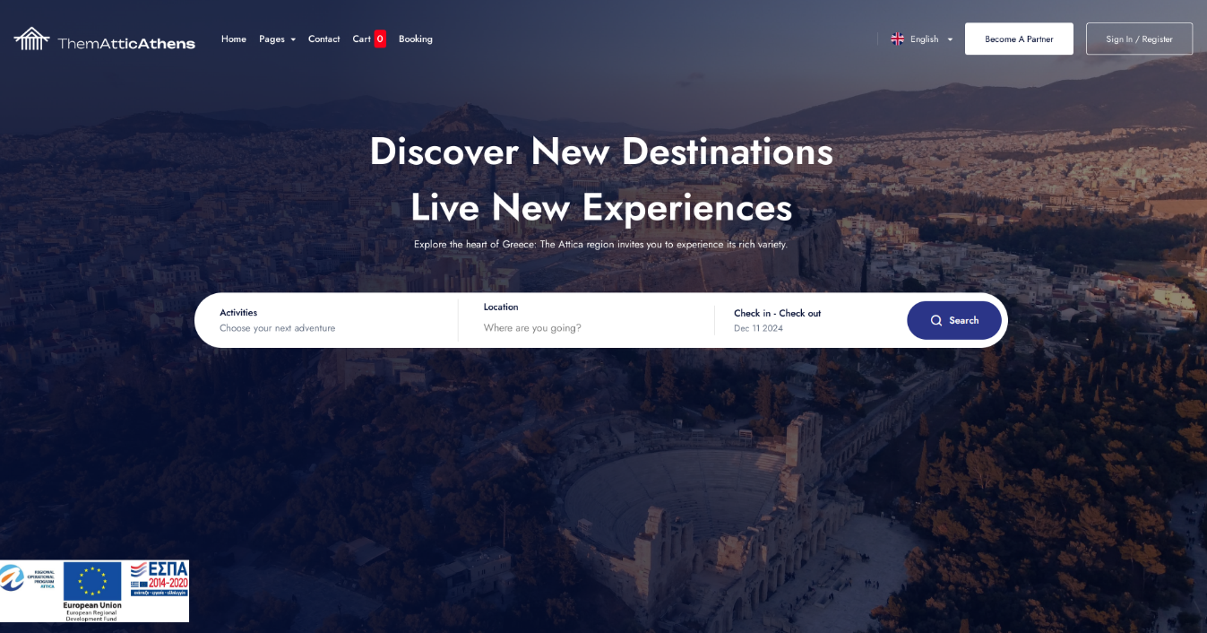
This guide will walk you through everything you need to get started on our platform. You'll learn how to register, set up your profile, and manage your activities.
Our goal is to support your business by providing a seamless, user-friendly platform where you can showcase your offerings and connect with a vibrant community interested in thematic tourism. Together, we can create memorable experiences for visitors and locals alike, highlighting the rich cultural and natural heritage of Attica.
ThemAtticAthens is a platform that offers easy and quick search for activities and accommodations in Athens. Below is a detailed guide to the main functionalities of the website:

1. How to Search:
The main search feature allows you to quickly find your ideal options.

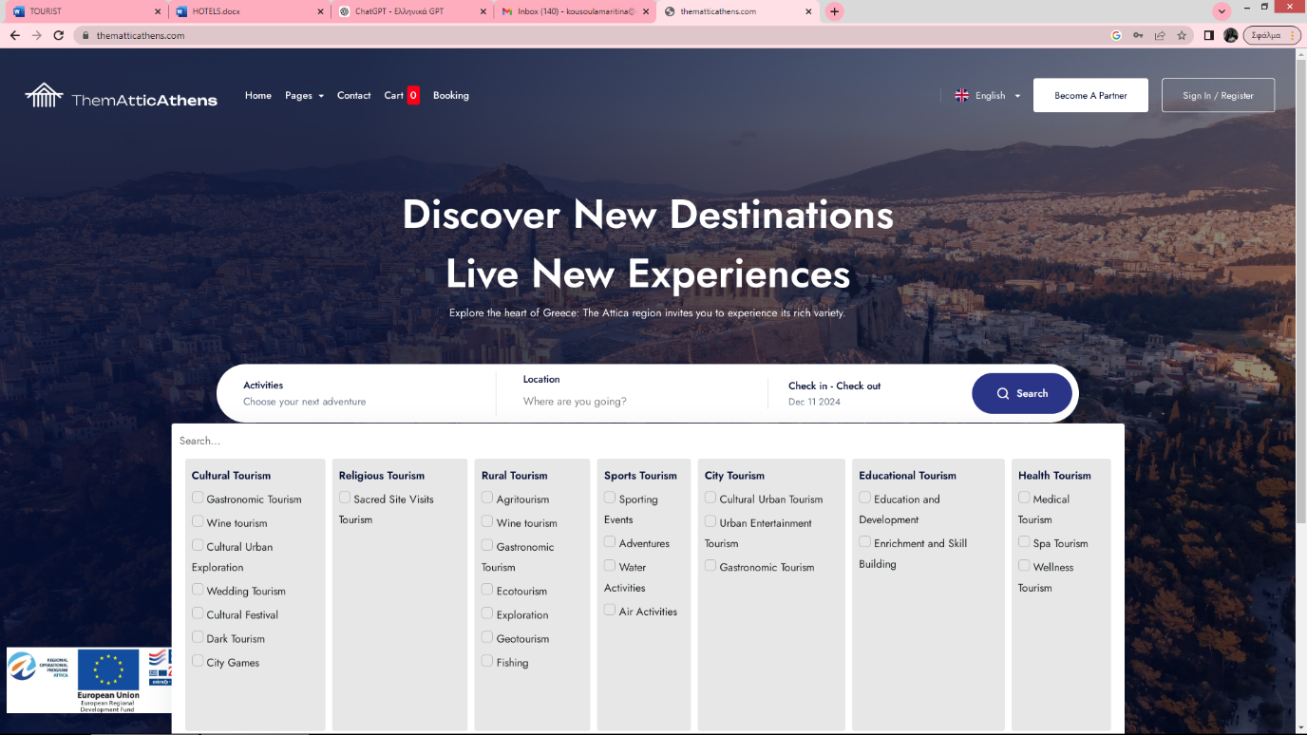
- Step 1: Fill in the fields for activity, location, and dates.
- Step 2: Click the SEARCH button.
- Step 3: Review the results displayed, which you can further sort or filter (e.g., by price or popularity).

Step 1.
Searching for Activities
On the homepage, you will find a dedicated section to browse and search for activities.
Select the category of activities that interests you (e.g., winetourism,tours, gastronomy, culture).

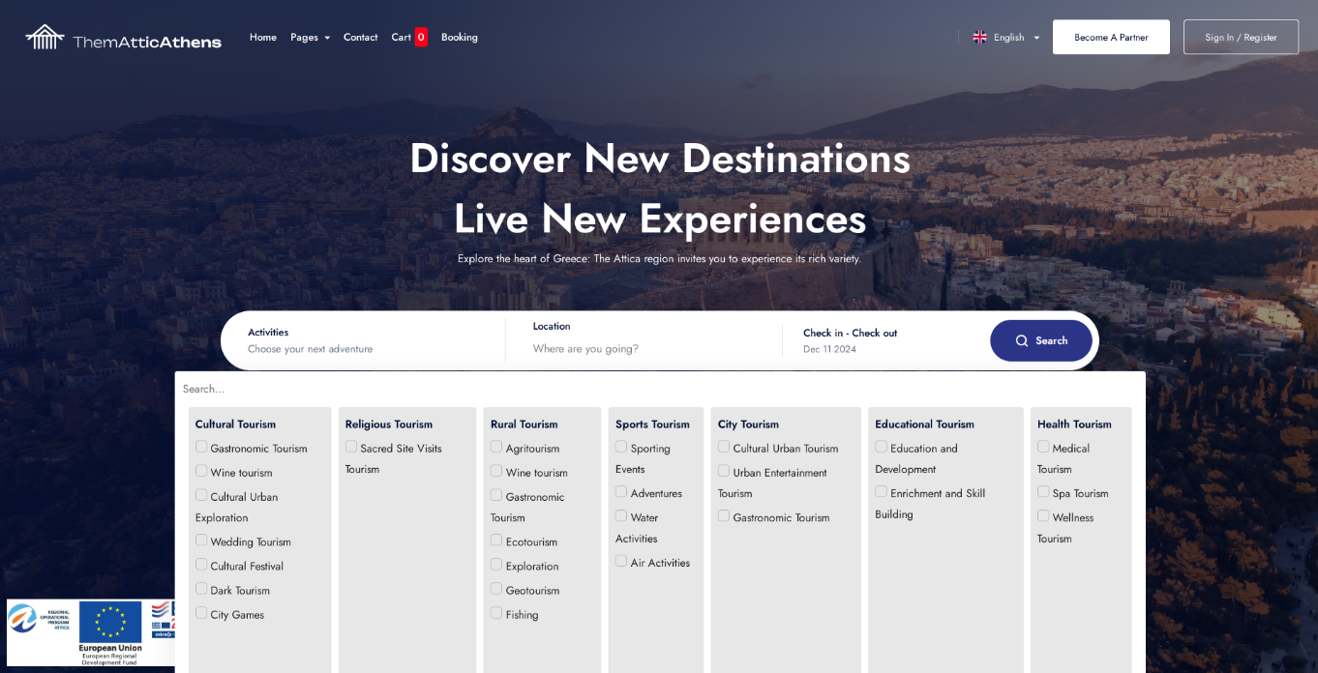

Customize your search using filters such as date, price, or location.

Click on an activity to view detailed information, including description, price, and available times.

Step 2.
Selecting a Location
The platform allows you to search for activities and accommodations in specific areas.
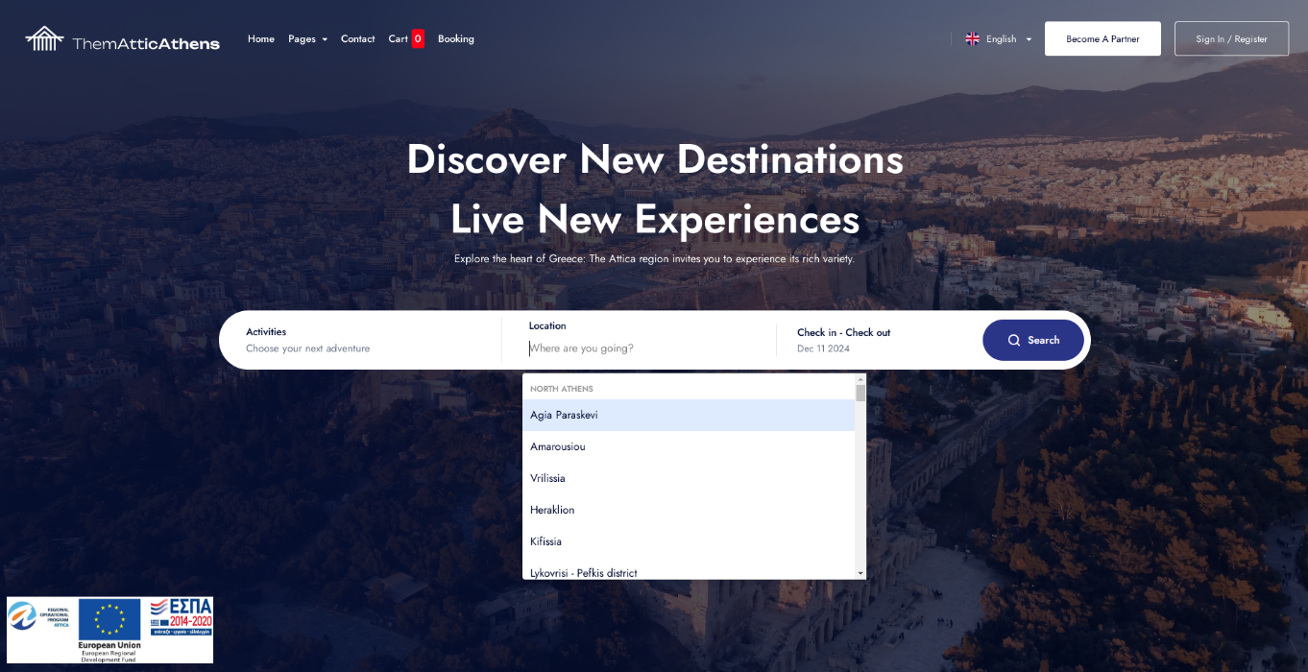
- In the "Location" field, type the area you are interested in (e.g., Athens Center, Plaka).
- Select from the suggestions that appear to narrow your search.
- The results will automatically adjust to the selected area.

Step 3.
Check-In and Check-Out
For booking accommodations, you need to specify your stay dates.

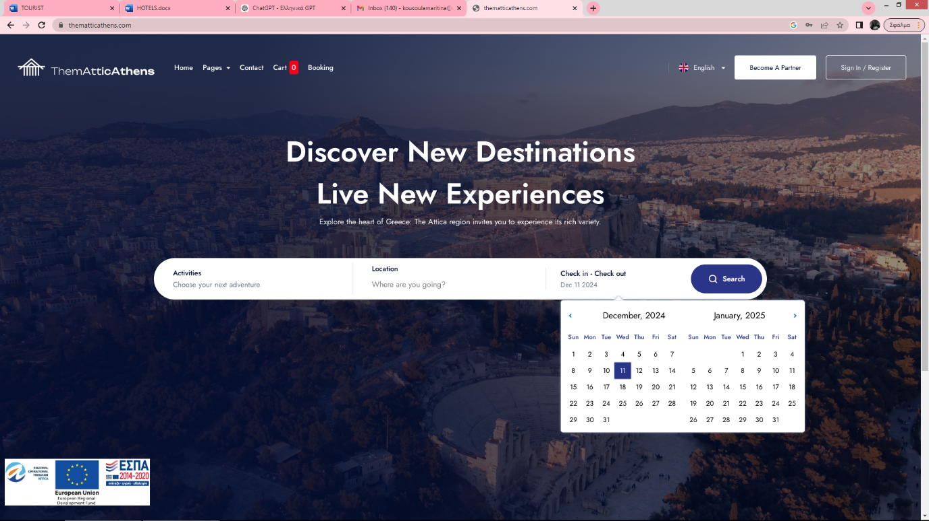
- 1: In the search section, you will find fields to input Check-In and Check-Out dates.
- 2: Click on the field and use the calendar to choose your preferred dates.
- 3: Ensure the dates are correct and align with your schedule before proceeding.

Alternatively,
You can use the search bar labeled "Search" to find the service you need. Simply type in the relevant keyword, and the results you are looking for will appear instantly.

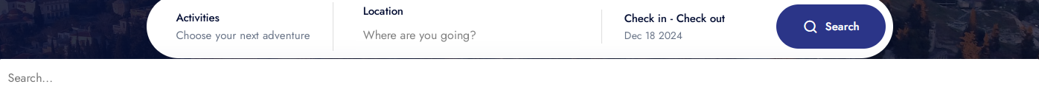

2. How to Review:
On the service page describing "Wine Tourism" on the Thematic Athens platform, the "Guest Reviews" section aims to showcase feedback and ratings from visitors who have experienced the service.
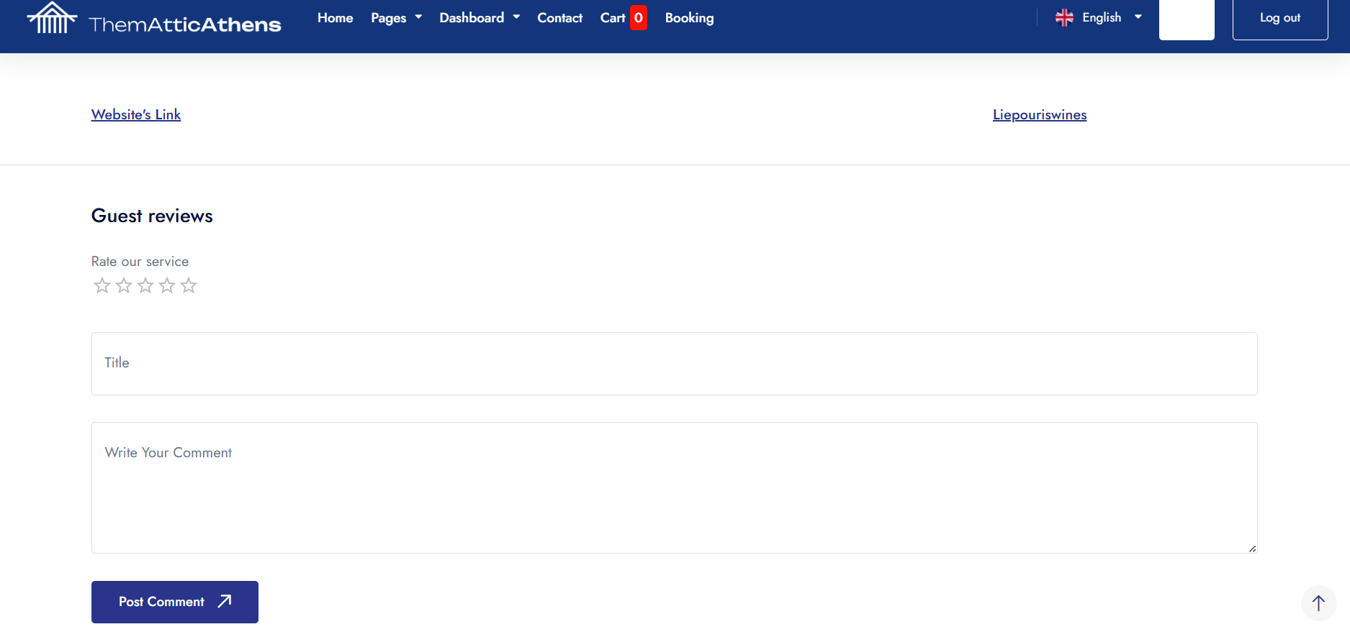
Specifically, this section includes:
- Ratings: Typically represented in a star-based format (e.g., 1 to 5 stars), summarizing the overall satisfaction of guests.
- Reviews: Written comments where guests describe their experiences, highlighting strengths and offering constructive feedback for improvement.
- User Experiences: The reviews often focus on specific aspects of the service, such as the quality of the wines, the guided tour, the ambiance, or the hospitality.
This section serves as a valuable resource for prospective users, providing an authentic and transparent overview of others' experiences to assist in informed decision-making. Additionally, it enhances the platform's credibility and trustworthiness.

3. How to Contact:
The "Contact" option on Thematic Athens platform provides users with the ability to communicate directly with the platform's management or support team.
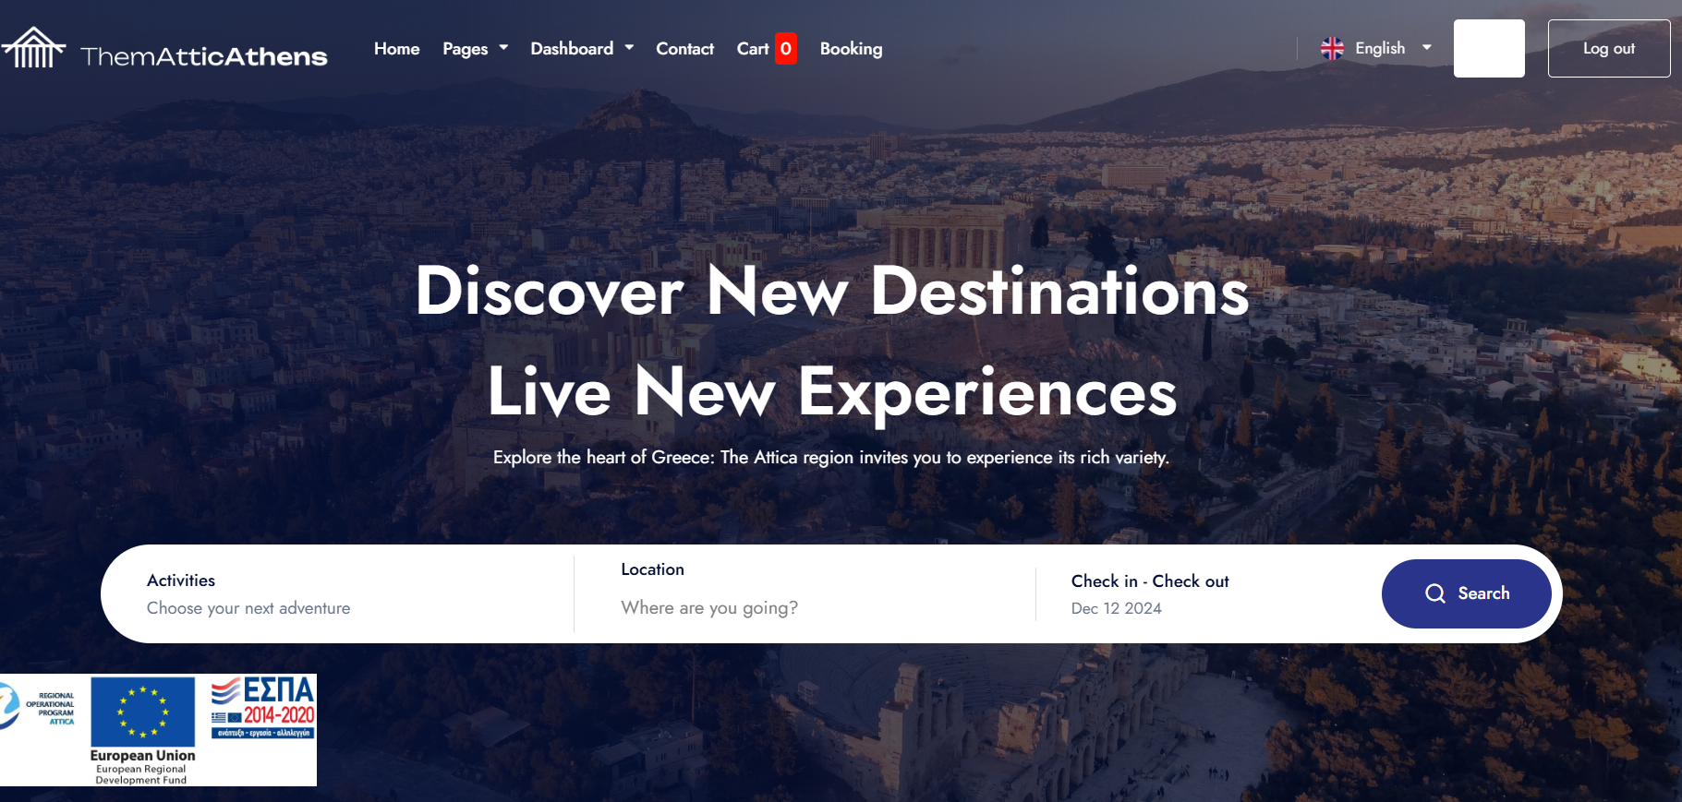

Typically, this option includes information and tools to facilitate the submission of inquiries, requests, or feedback, such as:
- Contact Form: A digital form where users can fill in their details (e.g., name, email) and the message they wish to send.
- Contact Details: Includes email addresses, phone numbers, or physical addresses for direct communication.
- Interactive Tools: In some cases, it may feature functionalities such as live chat or links to social media channels.
This option ensures two-way communication between users and the platform, enabling support, gathering feedback, and enhancing the overall user experience.

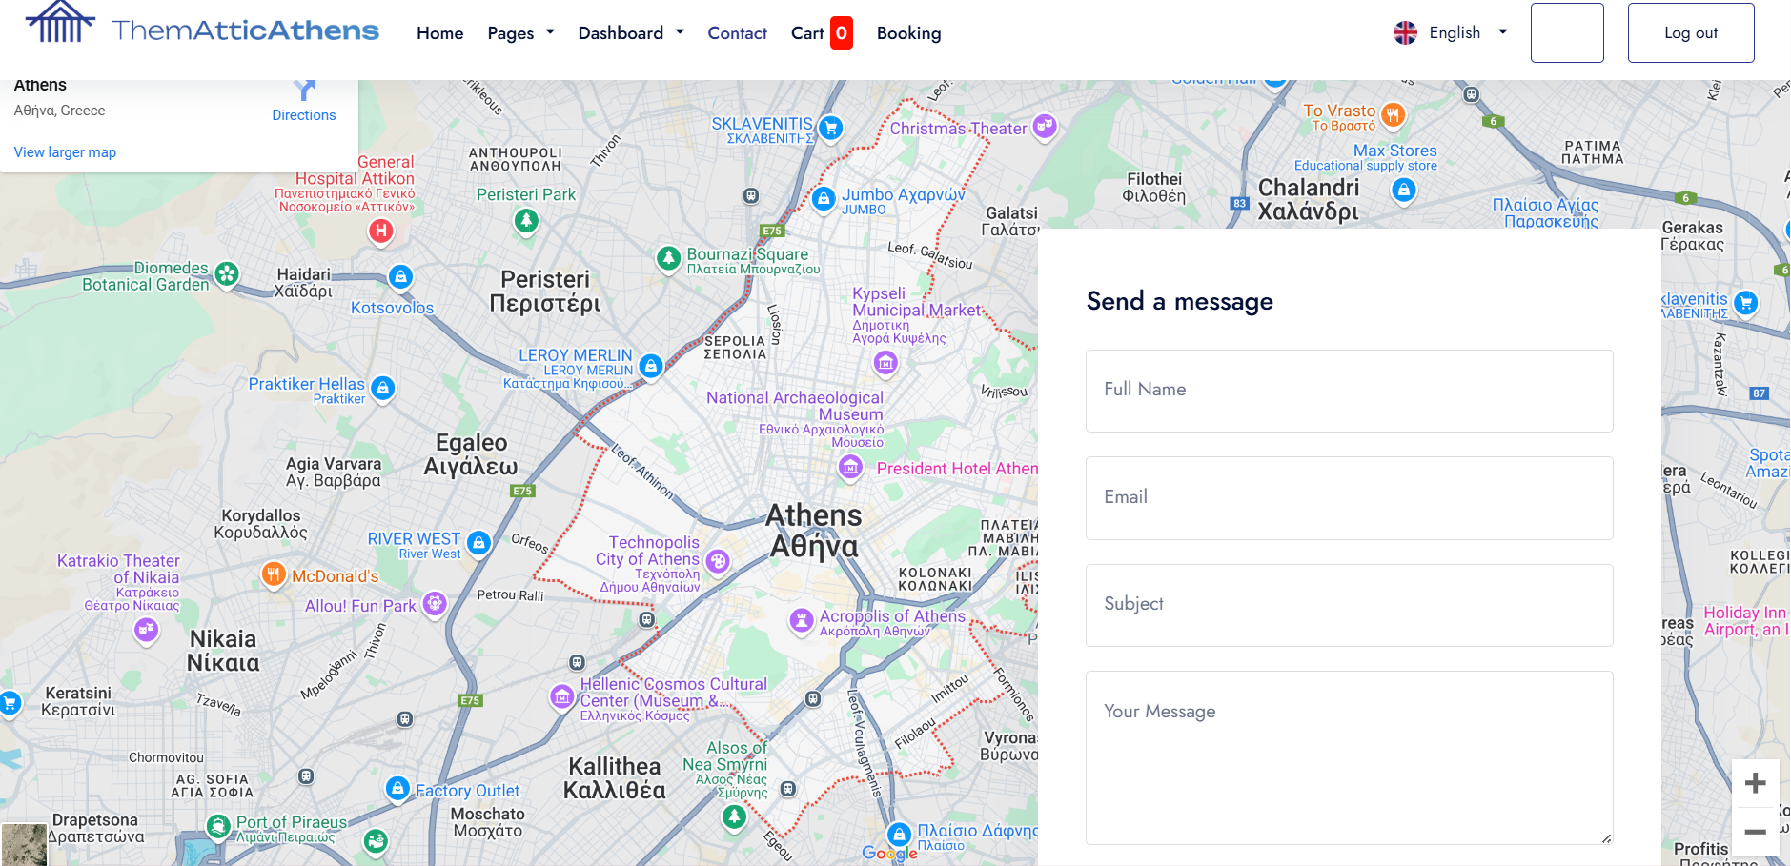

How to Search: An example

Below, an example will be provided specifically related to wine tourism. This example is intended to assist users in understanding how they can easily make a booking through the platform:
Guide for Searching Wine Tourism Activities as a Customer
Follow the steps below to find and book a wine tourism activity through the ThematicAthens.com platform:

Step 1: Visit the Homepage
- Navigate to the ThematicAthens.com website.
- On the homepage, you will find the search field for activities.

Step 2: Select the Activity Category
- In the Activities search field, type "Wine Tourism"
- Click on the relevant option that interests you, e.g., Wine Tasting and Winery Tour.
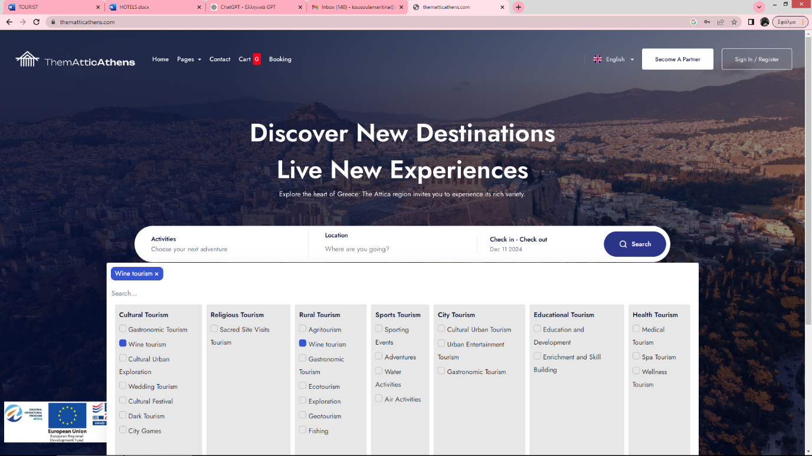
Step 3: Use Filters to Customize Your Search
- Location: Enter the area you wish to visit, e.g., Agia Paraskevi.
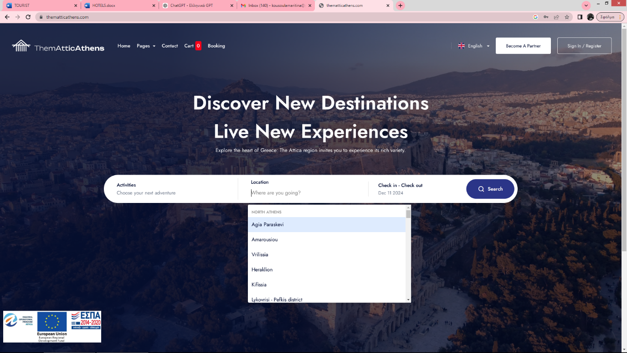
- Date (Check-in and Check-out):
-Open the calendar and select the date you would like to participate in the activity, e.g., 15th January 2024.
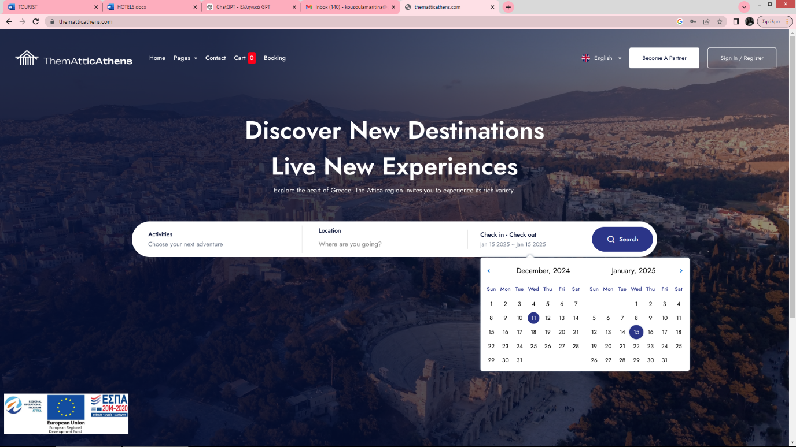
- Price Range: Use the price slider to select a range, e.g., €18–€62.
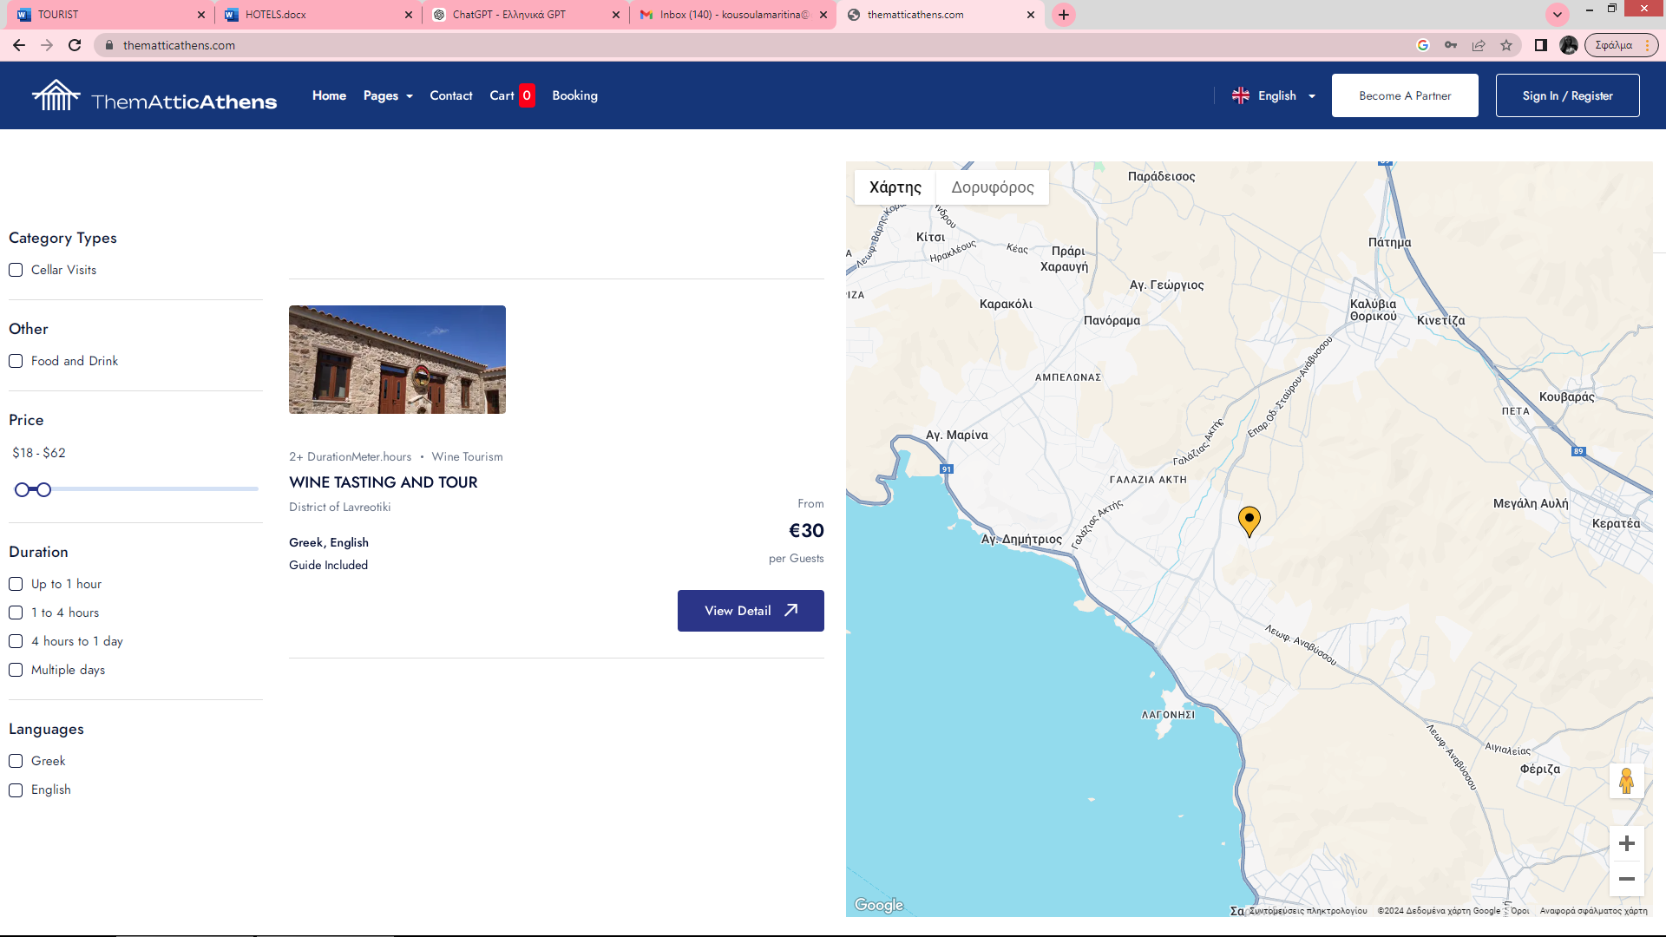
Click Search to view the results.

Step 4: Choose an Activity
From the displayed results, select an activity, such as:
"Wine Tasting and Winery Tour in Attica."
When you click on the activity, the following details will appear:
- Description: Detailed information about the experience. For example:
"Enjoy a guided tour of a historic winery in Attica, complete with a tasting session of five premium wines paired with local snacks."
- Available Times: 11:00 AM – 3:00 PM.
- Price: €70 per person.
- Includes: Guided tour, wine tasting, and local snacks (cheese & charcuterie).

Step 5: Make a Booking (Book Now)
- Click the Book Now button.
- Fill in the booking form with the following details:
  - Full name
  - Email address
  - Number of participants
- Confirm the date and time of the activity.

Step 6: Payment and Confirmation
- Complete the payment process using the platform's secure payment gateway.
- After payment, you will receive a confirmation email containing all the details of your booking.

Οnce you have selected the above items, you will have to add the number of customers who will participate and the system will automatically calculate the final amount.
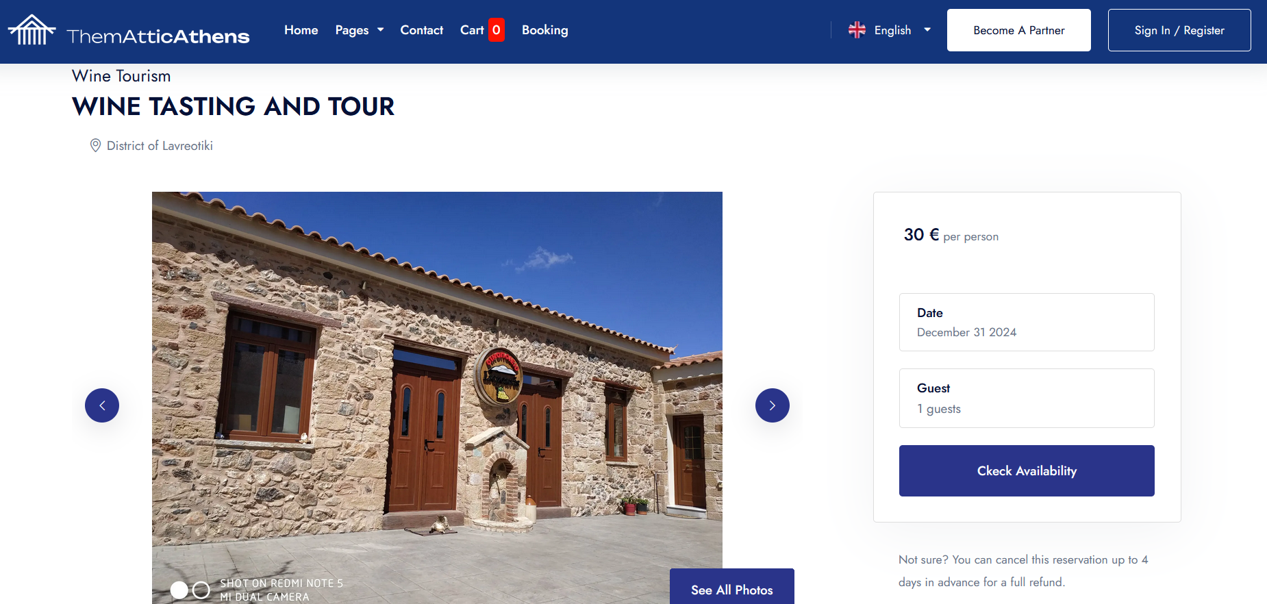

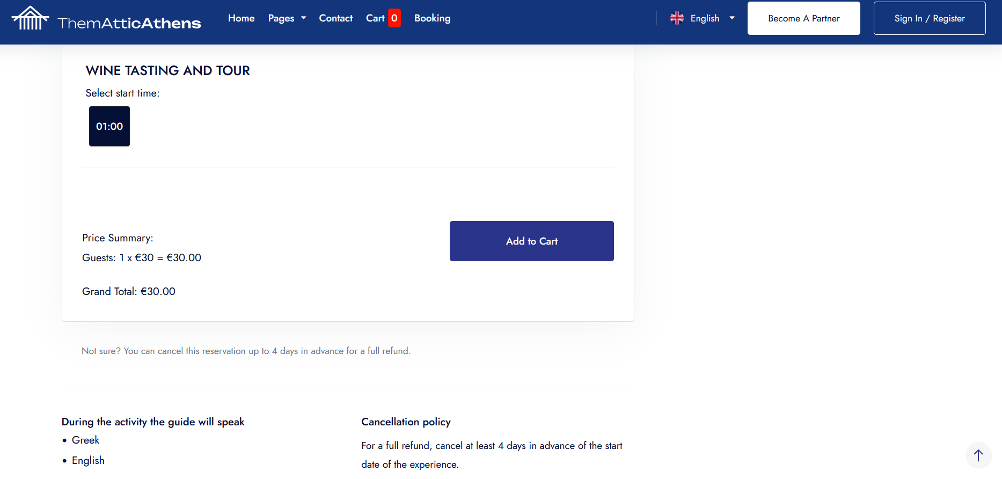

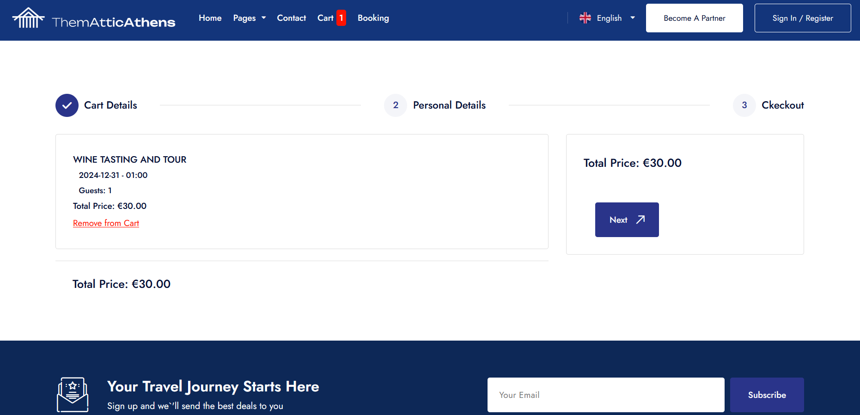
You will then fill in your personal details and your credit card details and click on the <<next>>> button.
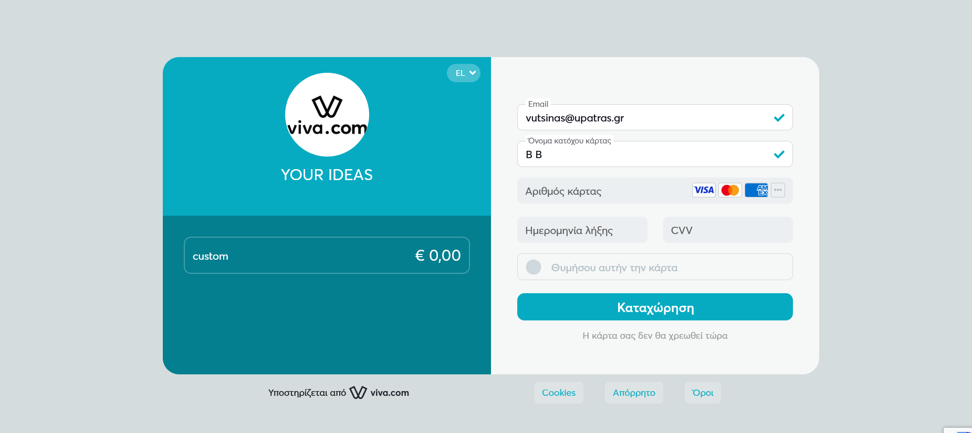

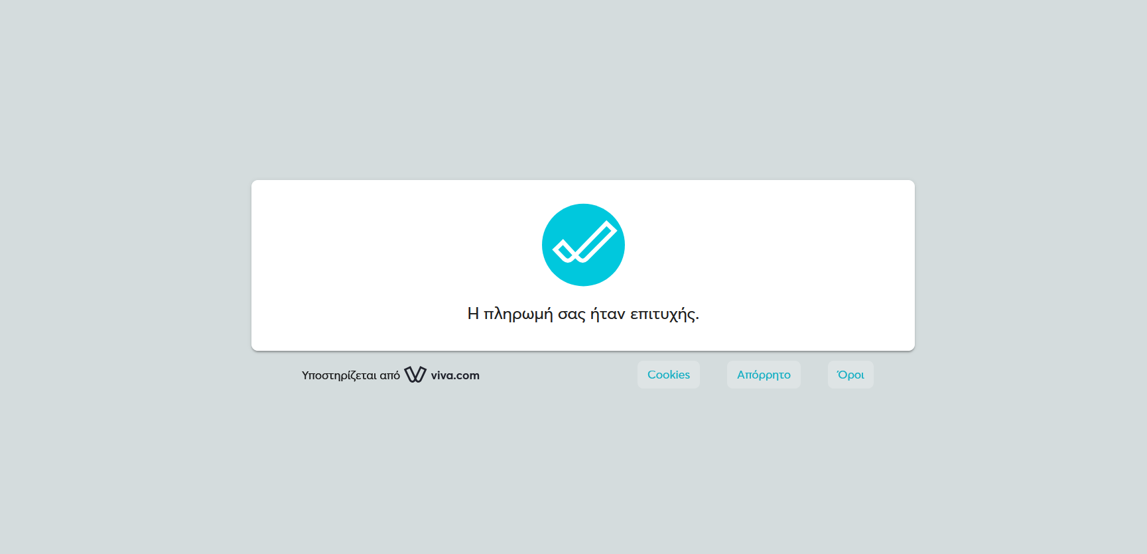
You will go to the home page and select <<Dashboard>> and choose <<Customer Booking History>>.
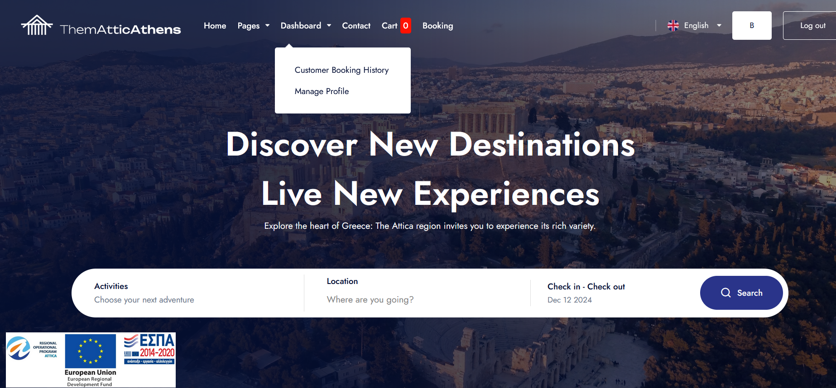
You will find detailed information about your reservation.
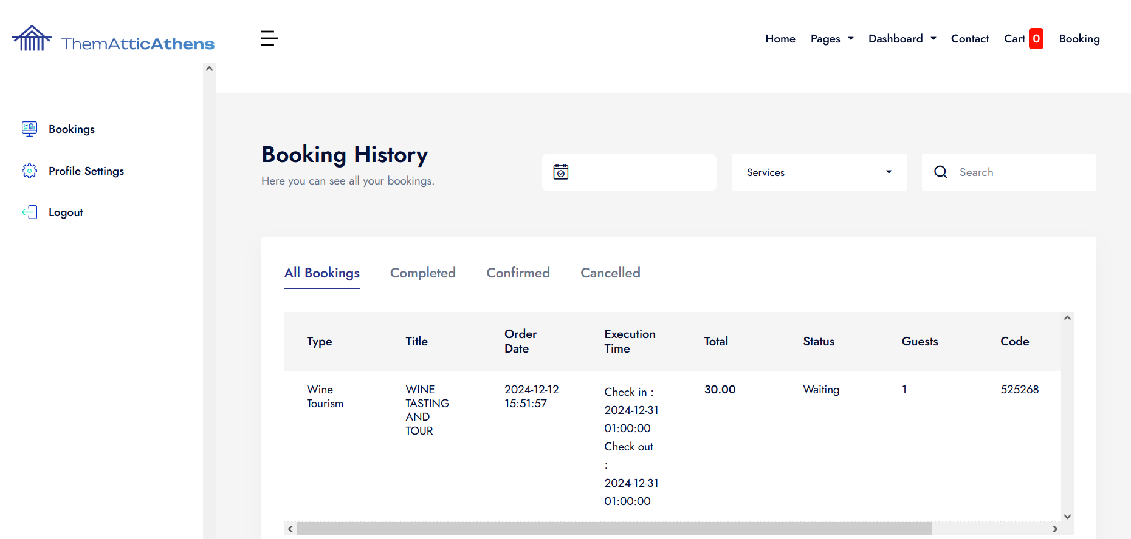

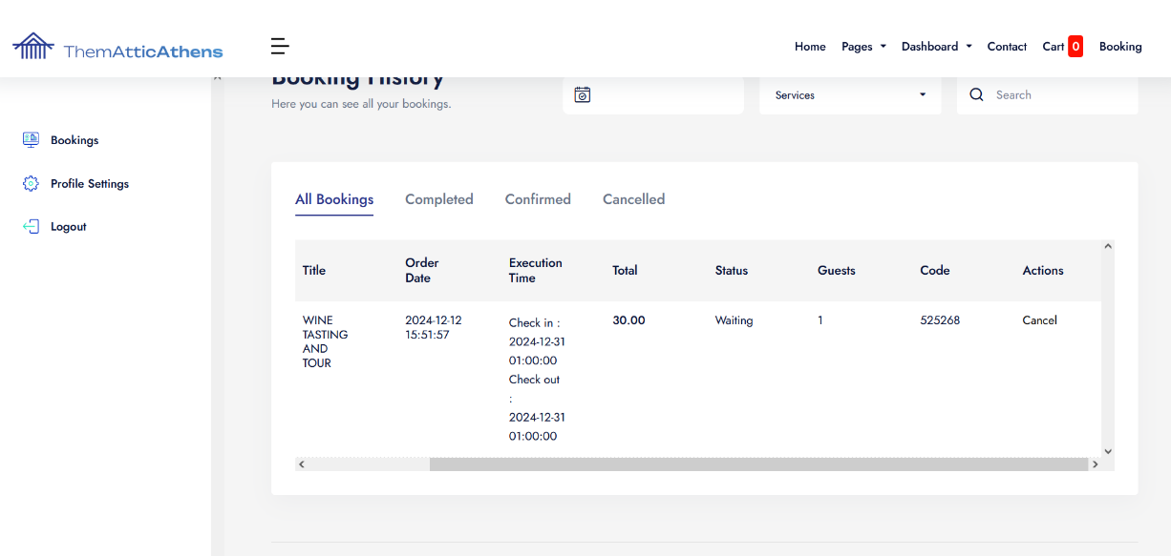

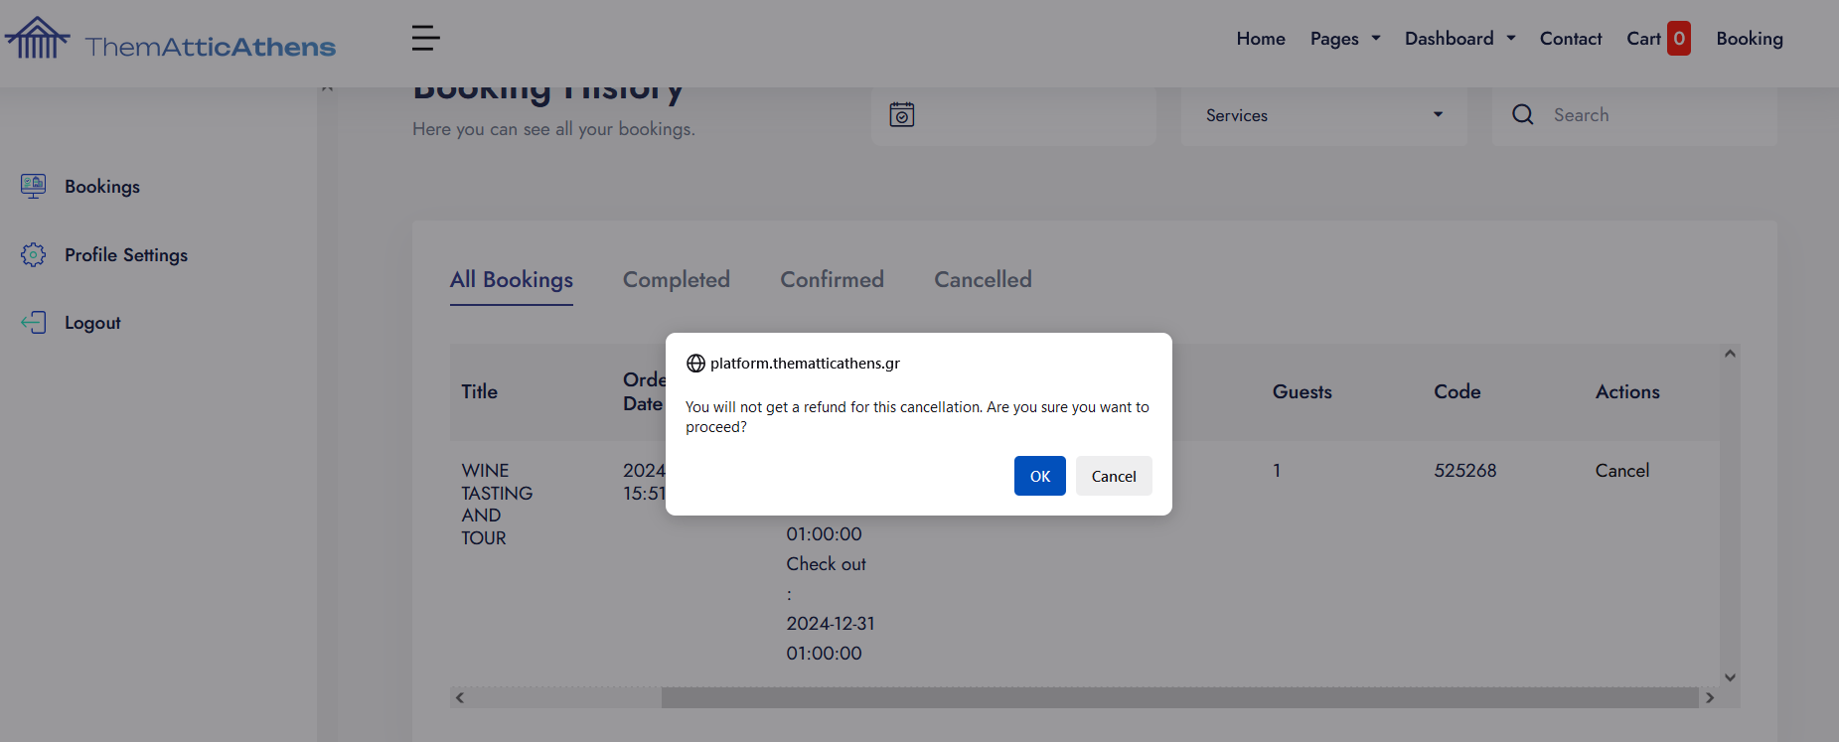

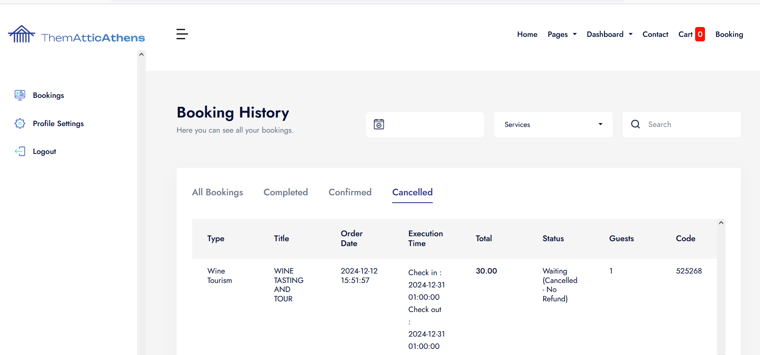

In the case you want to delete your account, you have to follow these steps:
Go to the Dashboard and select <<Manage Profile>>
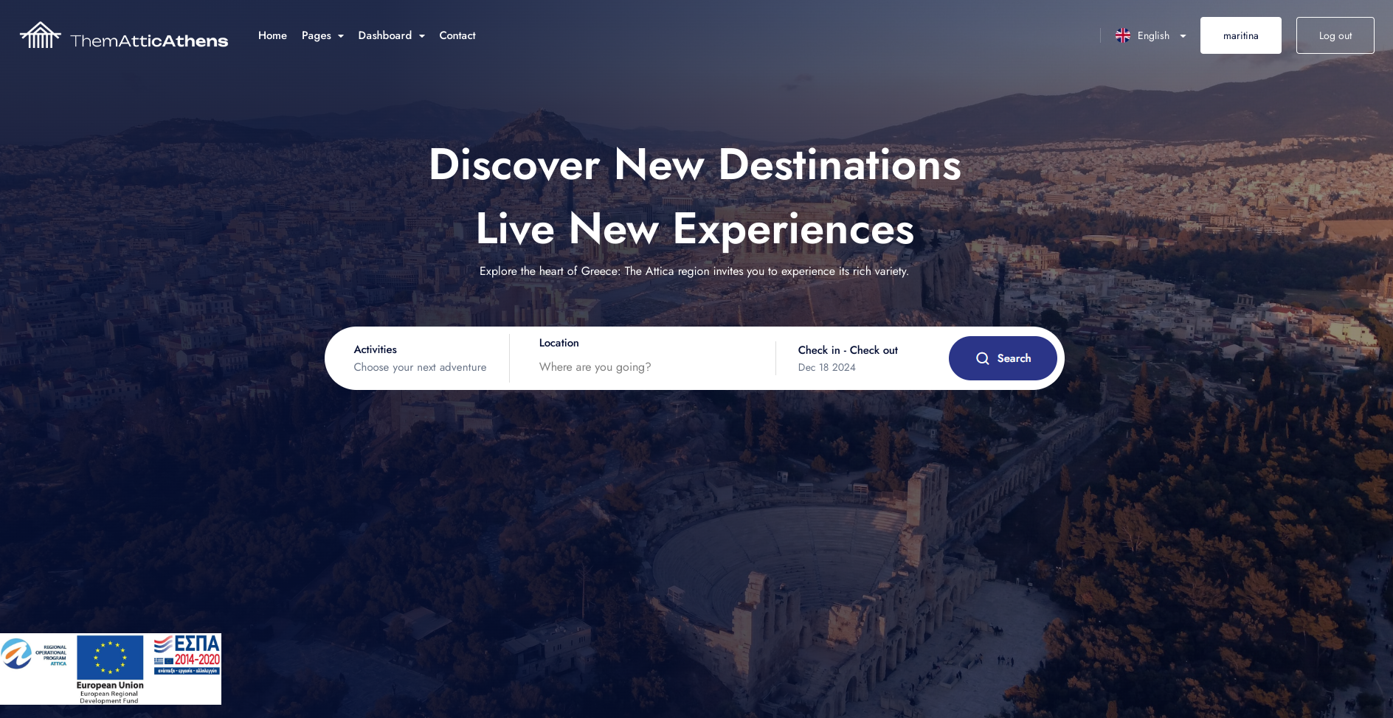
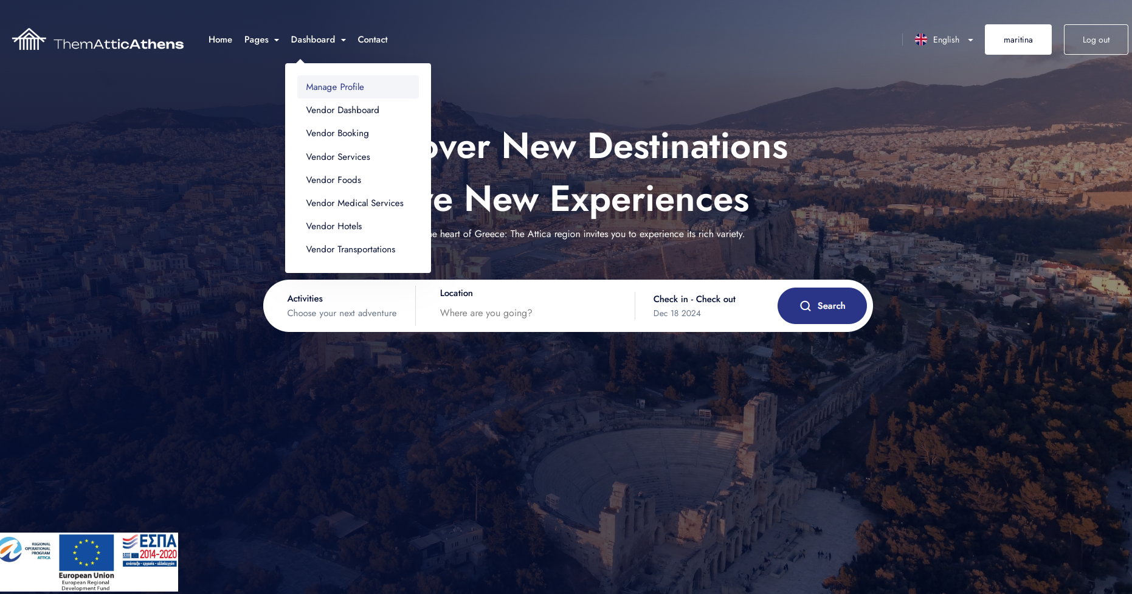
2. Click the button <<Delete Account>>
